**CA3001 – Programming and Data Structures using C**

**Assignment 2 : 22.12.2020**

**Q1.** Print “your name–SOA University”.

Ans - C Program & Output:

#include<stdio.h>

int main()

{

printf("Tattvamasi Mishra - SOA University");

return 0;

}

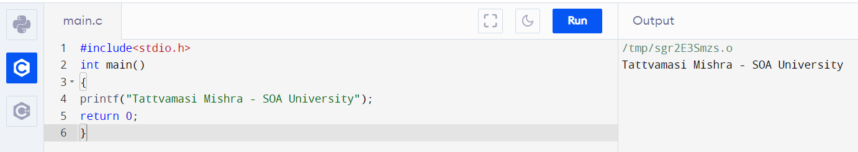

**Q2**. Print your name, mobile number and email id in different lines.

Ans - C Program & Output:

#include<stdio.h>

int main()

{

printf("Name - Tattvamasi Mishra\nNumber - 1234567892\nMail id - jsgfaeku@gmail.com\n");

return 0;

}

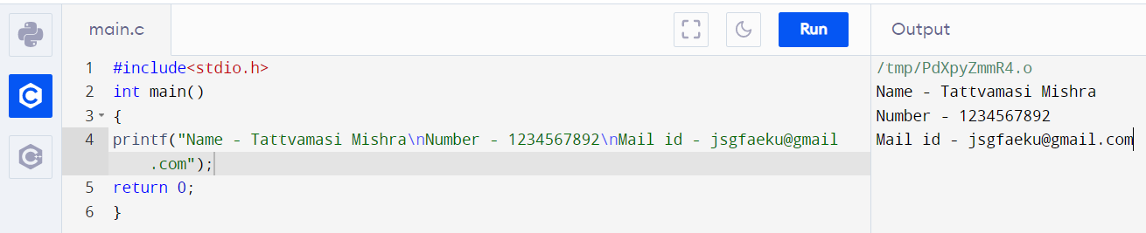

**Q3**. Get int, float and char as input, then print the same

Ans - C Program & Output:

#include <stdio.h>

int main()

{

int Integer;

char Character;

float InputFloat;

printf(" Please Enter a Character : ");

scanf("%c", &Character);

printf(" Please Enter an Integer Value : ");

scanf("%d", &Integer);

printf(" Please Enter Float Value : ");

scanf("%f", &InputFloat);

printf(" \n The Integer Value that you Entered is : %d", Integer);

printf(" \n The Character that you Entered is : %c", Character);

printf(" \n The Float Value that you Entered is : %f", InputFloat);

return 0;

}

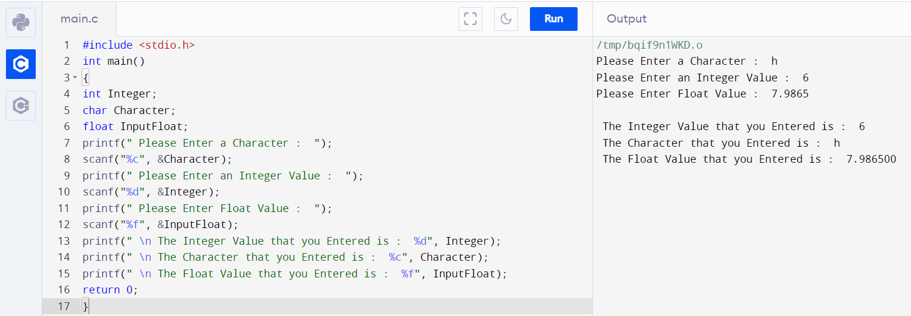

**Q4**. Find the cube of the given number

Ans - C Program & Output:

#include<stdio.h>

int main()

{

int n, cube;

printf("Enter a number:");

scanf("%d",&n);

cube = n*n*n;

printf("Cube of %d is: %d",n,cube);

return 0;

}

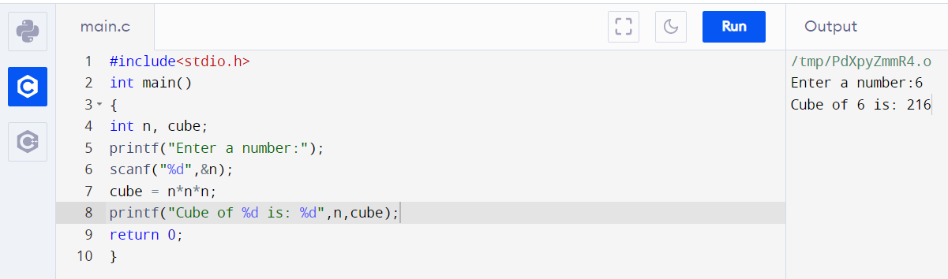

**Q5**. Find the sum of five given numbers

Ans – C Program & Output:

#include<stdio.h>

int main()

{

int a, b, c, d, e, sum;

printf("Enter five numbers:"\n);

scanf("%d%d%d%d%d",&a,&b,&c,&d,&e);

sum = a+b+c+d+e;

printf("Sum of given five numbers is:%d",sum);

return 0;

}

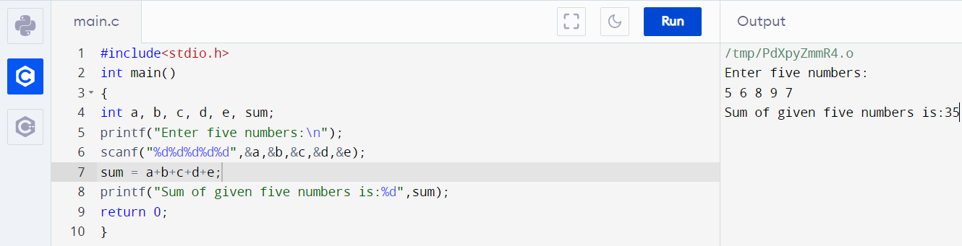

**Q6**. Find a student average mark given mark1 and mark2.

Ans – C Program & Output:

#include<stdio.h>

int main()

{

int m1, m2, average;

printf("Enter marks m1 and m2:");

scanf("%d %d",&m1,&m2);

average = (m1+m2)/2;

printf(" Average mark is:%d",average);

return 0;

}

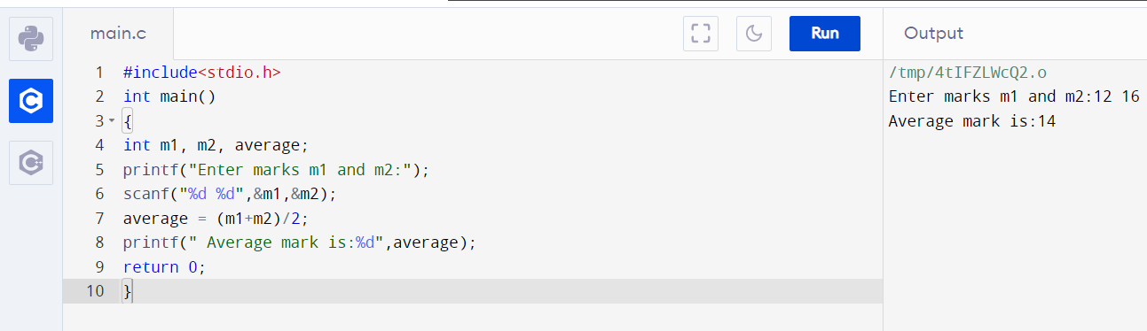

**Q7.** Calculate the total fine charged by library for late-return books. The charge is 0.20 INR for 1 day

Ans - C Program &Output:

#include<stdio.h>

int main()

{

int days;

float fine, charge = 0.20;

printf("Enter number of days:");

scanf("%d",&days);

fine = charge*days;

printf("Total fine = %f",fine);

return 0;

}

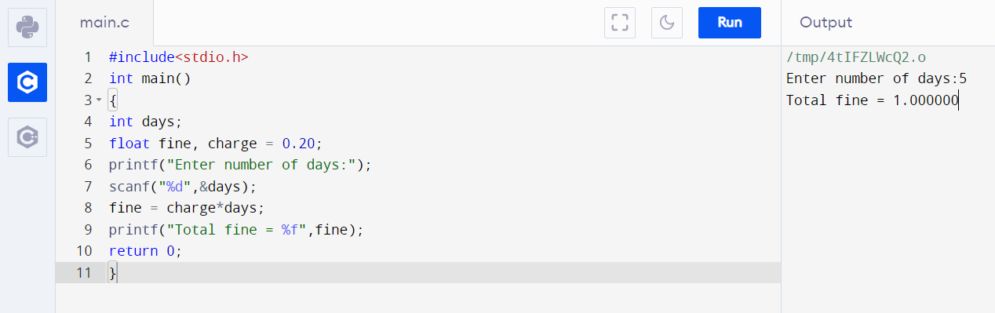

**Q8.** You had bought a nice shirt which cost Rs.29.90 with 15% discount. Count the nett price for the shirt.

Ans – C Program & 0utput:

#include<stdio.h>

int main()

{

float CP = 29.90, NP, discount = 0.15, discounted_price;

discounted_price = CP*discount;

NP = CP - discounted_price;

printf("Net price of the shirt is:%f",NP);

return 0;

}

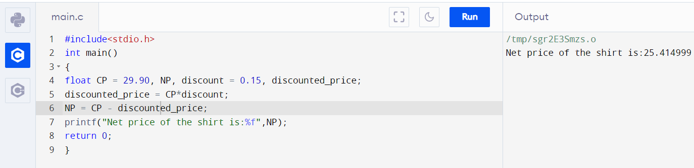

**Q9**. Swap two numbers with third variable.

Ans - C Program & Output:

#include<stdio.h>

int main()

{

int var1,var2,temp;

printf("Enter 2 variables:\n");

scanf("%d%d",&var1,&var2);

printf("Before swapping\nFirst Variable: %d\nSecond Variable: %d\n",var1,var2);

temp = var1;

var1 = var2;

var2 = temp;

printf("After Swapping\nFirst Variable: %d\nSecond variable: %d\n",var1,var2);

return 0;

}

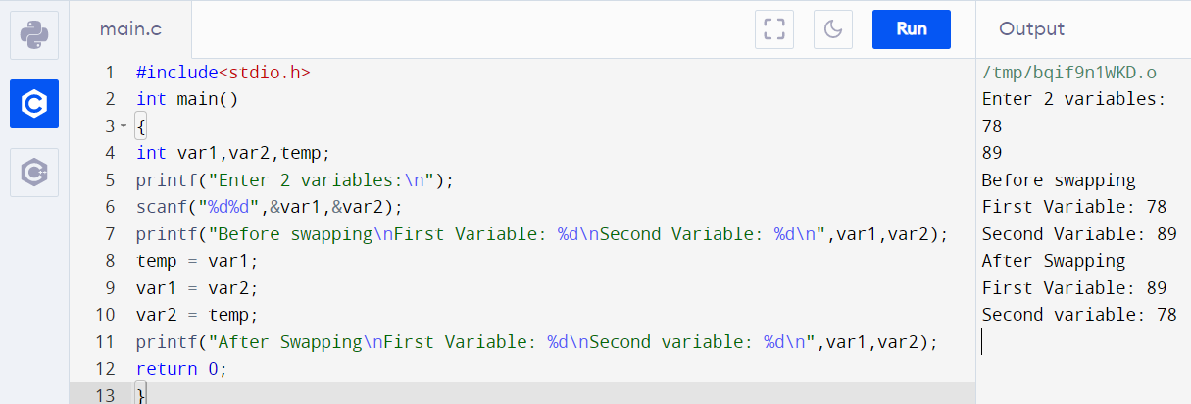

**Q10**. Swap two numbers without third variable(By + and –(or) By * and /)

Ans - C Program & Output:

#include<stdio.h>

int main()

{

int a=10, b=20;

printf("Before swapping\na= %d\nb= %d",a,b);

a=a+b;//a=30 (10+20)

b=a-b;//b=10 (30-20)

a=a-b;//a=20 (30-10)

printf("\nAfter swapping\na=%d\nb=%d",a,b);

return 0;

}

